

**PYTHON LAB**

**ASSIGNMENT**

NAME : Bapan Ghosh

STUDENT ID : 201001270057

Stream.: MCA(first semester)

DATE OF SUBMISSION : 05/03/2021

Q 1. *1.write a program to count number of vowels in a given string.*

**CODE :**

*string=input("Enter string:")*

*vowels=0*

*for i in string:*

*if(i=='a' or i=='e' or i=='i' or i=='o' or i=='u' or i=='A' or i=='E' or i=='I' or i=='O' or i=='U'):*

*vowels=vowels+1*

*print("Number of vowels are:")*

*print(vowels)*

**OUTPUT :**

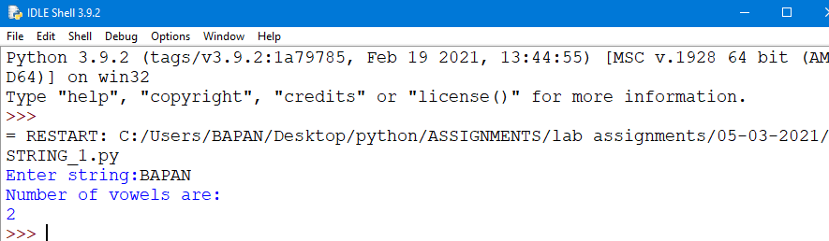

Q 2 . *A program is required to be developed for abbreviating a string as illustrated below: Damodar Valley Corporation will be abbreviated to DVC.*

**CODE :**

*def stringAbbreviation (str):*

*result = ""*

*v = True*

*for i in range(len(str)):*

*if (str[i] == ' '):*

*v = True*

*elif (str[i] != ' ' and v == True):*

*result += (str[i])*

*v = False*

*return result*

*str = input("enter the string separated by space")*

*print(stringAbbreviation(str))*

**OUTPUT :**

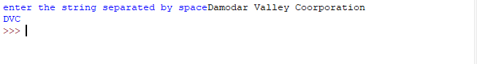

Q 3 . *A program is required to be developed for abbreviating a string as illustrated below:*

**CODE :**

*(i) Tapan Kumar Ghosh will become T. K. Ghosh*

*Answer:-*

*s=input("enter your name:")*

*c=0*

*print(s[0],end='.')*

*for i in range(1,len(s)):*

*if(s[i]==' '):*

*c=c+1*

*if(s[i-1]==' ' and c==1):*

*print(s[i],end='.')*

*if(s[i-1]==' 'and c>1):*

*for j in range(i,len(s)):*

*print(s[j],end='')*

**OUTPUT :**

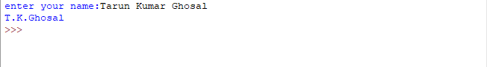

*3. (||) A program is required to be developed for abbreviating a string as illustrated below:*

*(ii) Ranit Saha will become R. Saha*

**CODE :**

*s=input("enter your name:")*

*c=0*

*pos=0*

*for i in s:*

*if(i==' '):*

*c=c+1*

*print(s[0]+'.',end='')*

*for i in s:*

*pos=pos+1*

*if(i==' ' and c==1):*

*break*

*for i in range(pos,len(s)):*

*print(s[i],end='')*

**OUTPUT :**

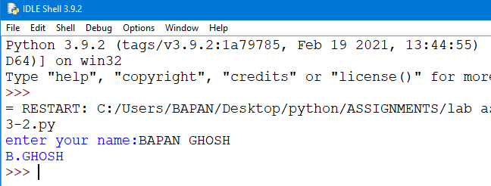

Q 4. *A program is required to be developed to test whether a given word is a palindrome or not.*

**CODE :**

*string=input("Enter string:")*

*if(string==string[::-1]):*

*print("The string is a palindrome")*

*else:*

*print("The string isn't a palindrome")*

**OUTPUT :**

